|  |  |  |  |  |  |
| --- | --- | --- | --- | --- | --- |
| **Time** | **Monday (9-7)**  **No school** | **Tuesday (9-8)** | **Wednesday (9-9)**  **SPECIAL TODAY!** | **Thursday (9-10)** | **Friday (9-11)** |
| **8:00-8:15** | **SEL Journal Writing**  -have your child write or draw in their journal every morning before class  -this is for your child to have their minds ready for the day, this can also be used for goal setting  -ask them questions like:   1. How was yesterday? 2. Did something happen that made you happy, sad, excited, etc? 3. Did you help somebody yesterday? 4. What are you thankful for? 5. What is your goal for today? 6. How are you feeling this morning? 7. Write down anything you like. | | | | |
| **8:15-8:45** | **Spelling Words**  **(Sep. 8th-18th)**  zählen-to count  die Zahl-number  einige-some  jeder-everybody  ihre-her  schreiben-to write  niemand-nobody  zeigen-to show  schauen-to look  hören-to hear  zusammen-together | **SEL ZOOM**  **with Frau Glenn** | **SEL ZOOM**  **with Frau Glenn** | **SEL ZOOM**  **with Frau Glenn** | **SEL ZOOM**  **with Frau Glenn** |
| **Materials:**  -SEL journal  -pencil, colored pencils | **Materials:**  -SEL journal  -pencil, colored pencils | **Materials:**  -SEL journal  -pencil, colored pencils | **Materials:**  -SEL journal  -pencil, colored pencils |
| **8:45-9:15** | **German ZOOM**  **with Frau Glenn** | German independent work (workbooks/Canvas)  -go to German CANVAS course and click on Wednesday lesson  -complete quiz when done  🡪you will have to read a Conni book again (PDF is in the Canvas course), followed by a video which will read the book aloud (since I know it’s a little more difficult), at the end complete the quiz  -practice spelling words on Quizlet (link is on German Homepage on Canvas) | **German ZOOM**  **with Frau Glenn** | **German ZOOM**  **with Frau Glenn** |
| **Materials:**  -Kleines Monster book  -Kleines Monster workbook  -pencil, colored pencils | **Materials:**  -Kleines Monster book  -Kleines Monster workbook  -pencil, colored pencils | **Materials:**  -Kleines Monster book  -Kleines Monster workbook  -pencil, colored pencils |
| **9:15-9:45** | German independent work (workbooks/Canvas)  -go to German CANVAS course  -click on Tuesday  🡪You will be able to see the new spelling words there. I will introduce them in small groups, so no need to go over them yet.  There is also a Quizlet link for your child to practice the words going forward.  We will have these words for 2 weeks. | German independent work (workbooks/Canvas)  -go to German CANVAS course  -click on Thursday  -it will give your child instruction on what to do in their workbook  -no quiz today | German independent work (workbooks/Canvas)  -go to German CANVAS course  -click on Friday  -take quiz |
| **9:45-10:15** |  | **Math ZOOM**  **with Frau Glenn**  *we will start the practice quiz on page 71-74, I will focus on the more difficult questions with them | Math independent work (workbooks/Canvas)   1. Go to EnVision to do your Unit 1 Test 2. Use manipulatives, number line, paper and pencil for help.   **🡪See at the bottom of the document for login instructions** | **Math ZOOM**  **with Frau Glenn** | **Math ZOOM**  **with Frau Glenn** |
|  | **Materials**  -German Envision workbook  -Ziplock bag with math manipulatives  -pencil, colored pencil | **Materials**  -German Envision workbook  -Ziplock bag with math manipulatives  -pencil, colored pencil | **Materials**  -German Envision workbook  -Ziplock bag with math manipulatives  -pencil, colored pencil |
| **10:15- 10:45** |  | Math independent work (workbooks/Canvas)   1. Finish pages 71-74 2. This is our practice test 3. You can find the same practice test in English in their English envision math workbooks. You can choose if you would rather go over it with your child. The actual test will also be in ENGLISH. | Math independent work (workbooks/Canvas)   1. Finish your math test in EnVision | Math independent work (workbooks/Canvas)   1. Do page 83 (and 84, if time allows) in workbook 2. Do CANVAS course 2-1 | Math independent work (workbooks/Canvas)   1. Do page 89 (and 90, if time allows) in workbook 2. Do CANVAS course 2-2 |
| **10:45 - 11:15** |  | **RECESS** | **RECESS** | **RECESS** | **RECESS** |
| **11:15 – 12:00** |  | **Special Area Class**  **DAY 6: MEDIA** | **Special Area Class**  **DAY 1: MUSIC** | **Special Area Class**  **DAY 2: SCIENCE LAB**  **(no live Zoom meeting, go to her Canvas course)** | **Special Area Class**  **DAY 3: TECHNOLOGY** |
| **12:00-12:30** |  | **LUNCH** | **LUNCH** | **LUNCH** | **LUNCH** |
| **12:30-1:00** |  | **Social Studies ZOOM**  **with Frau Glenn** | Science/Social Studies independent work in Canvas  -go to Social Studies CANVAS course  -this course can be complete in a self-paced manner  *Frau Glenn is available for help via phone or Zoom | 12:30-12:45 Science independent work Canvas  -go to CANVAS course  -click on “enter here”  -click on Thursday lesson    🡪because, we have not finished 1-3 last week, we will talk about it again today  **12:45-1:00 Science ZOOM**  **with Frau Glenn** | 12:30-12:45 Science independent work Canvas  -go to CANVAS course  -click on “enter here”  -click on Thursday lesson  🡪lesson 1-4  **12:45-1:00 Science ZOOM**  **with Frau Glenn** |
|  | **Material:**  -“Sozialkunde” workbook  -pencil, colored pencils | **Material:**  -“Naturwissenschaft” workbook  -pencil, colored pencils | **Material:**  -“Naturwissenschaft” workbook  -pencil, colored pencils |
| **1:00 – 1:20**  *see below for more info |  | **German Group 1 ZOOM with Frau Glenn**  Materials:  German journal  Conni Uebungsheft | Continue as needed: Science/ Social Studies independent work in Canvas | **Math Group 1 ZOOM with Frau Glenn** | **German Group 1 ZOOM with Frau Glenn**  Materials:  German journal  Conni Uebungsheft |
| **1:25-1:45**  *see below for more info |  | **German Group 2 ZOOM with Frau Glenn**  Materials:  German journal  Conni Uebungsheft | Complete any unfinished work | **Math Group 2 ZOOM with Frau Glenn** | **German Group 2 ZOOM with Frau Glenn**  Materials:  German journal  Conni Uebungsheft |
| **1:50-2:10**  *see below for more info |  | **German Group 3 ZOOM with Frau Glenn**  Materials:  German journal  Conni Uebungsheft | Complete any unfinished work  *Frau Glenn is available for help via phone or Zoom | **Math Group 3 ZOOM with Frau Glenn** | **German Group 3 ZOOM with Frau Glenn**  Materials:  German journal  Conni Uebungsheft |
| **2:15-2:35**  *see below for more info |  | **German Group 4 ZOOM with Frau Glenn**  Materials:  German journal  Conni Uebungsheft | Complete any unfinished work  *Frau Glenn is available for help via phone or Zoom | **Math Group 4 ZOOM with Frau Glenn** | **German Group 4 ZOOM with Frau Glenn** Materials:  German journal  Conni Uebungsheft |
| **2:35-3:00** |  | Complete any unfinished work  *Frau Glenn is available for help via phone or Zoom | Complete any unfinished work  *Frau Glenn is available for help via phone or Zoom | Complete any unfinished work  *Frau Glenn is available for help via phone or Zoom | Complete any unfinished work  *Frau Glenn is available for help via phone or Zoom |

**\*SMALL GROUPS:**

-only log in to Zoom for your child small group time

-for math small groups, they should have their German Envision workbooks, math manipulatives, pencil, colored pencils

-for German small groups, Deutsch journal, pencil, colored pencil, Kleines Monster book and workbook, Conni Uebungsheft

**\*\*1:00-2:35 when NOT in a small group with Frau Glenn:**

-use this time to complete any unfinished work in CANVAS or in the workbooks

-this time should also be used for some independent reading (books can be any language), if you would like to challenge your child more, have them write down the title, author, main characters, and what happens in the beginning, middle and end

How to login to your child’s Unit 1 math assessment:

-if you have done this already last Friday, you should be familiar with the steps. If you have not done the quick check quiz on Friday, please try to login on Tuesday so you know how to get there by Wednesday for the test.

1. Go to the NCEdcloud/Rapid Identity app on your iPad
2. Sign in using the student number and password (should be Cmsx2031)
3. This will redirect you to a page with various apps>>>>click on CLEVER (big blue C)

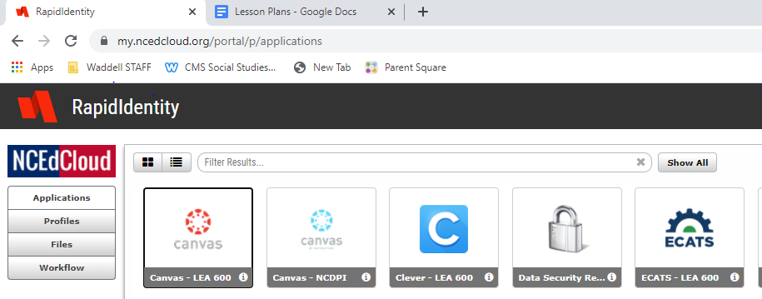

1. Click on SAVVAS/Easy Bridge (formerly: Pearson/Envision) (for me it’s towards the bottom of the page)

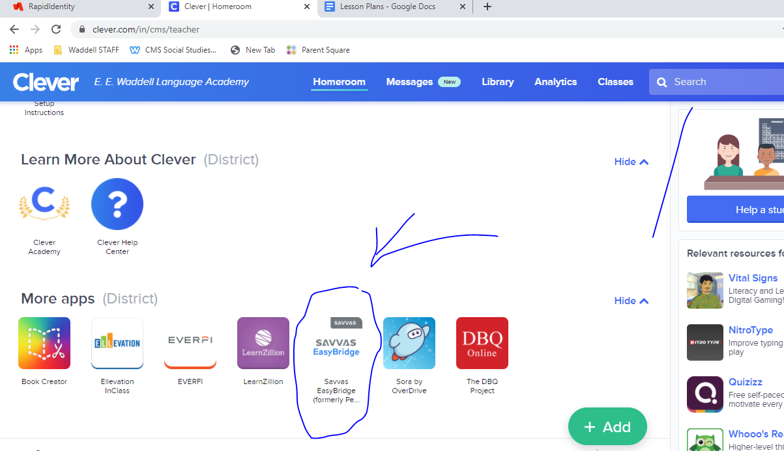

1. Now you will see this screen, click on the 2017 version

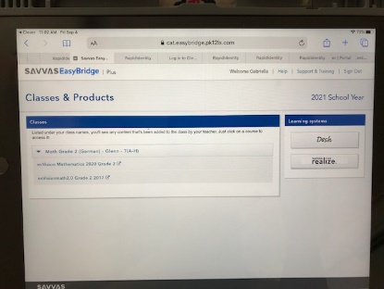

1. The student should be automatically signed in and the test should pop up under Class/assignments (middle of screen) 