Frau Glenn: 2nd Grade German
IPAD Information and Zoom Etiquette

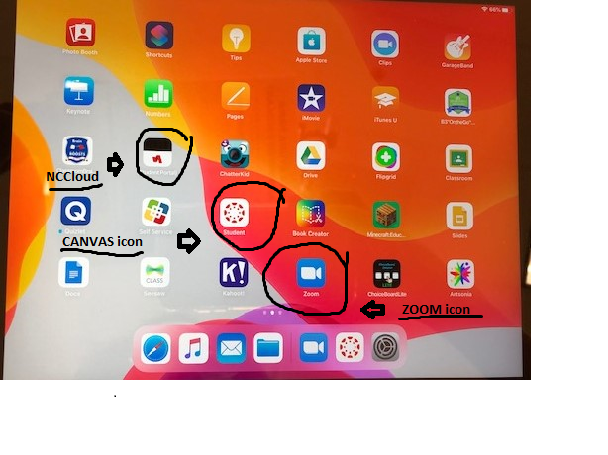
☆ZOOM APP☆
Here is the zoom ID number for my class, and the password:
- Meeting ID: 842 8375 6503
- Passcode: glenn

1) Touch the ZOOM icon (blue). If you cannot see it on one screen, swipe to next page. 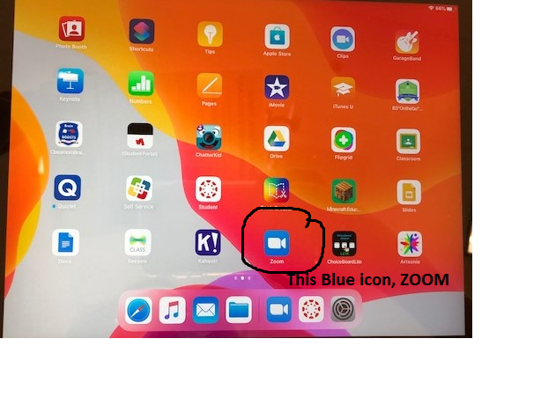

2) Touch the “join a meeting” on the bottom.
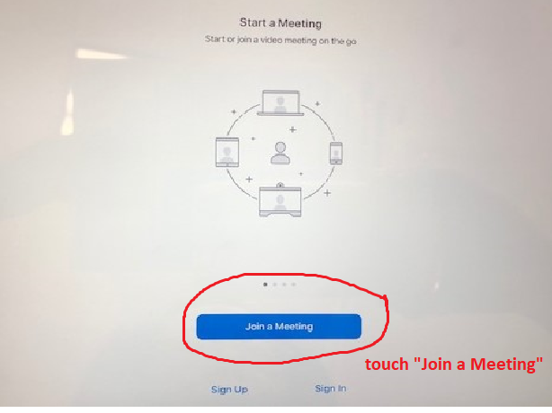

3) Put the Meeting ID #. Please DO NOT change your child’s name.
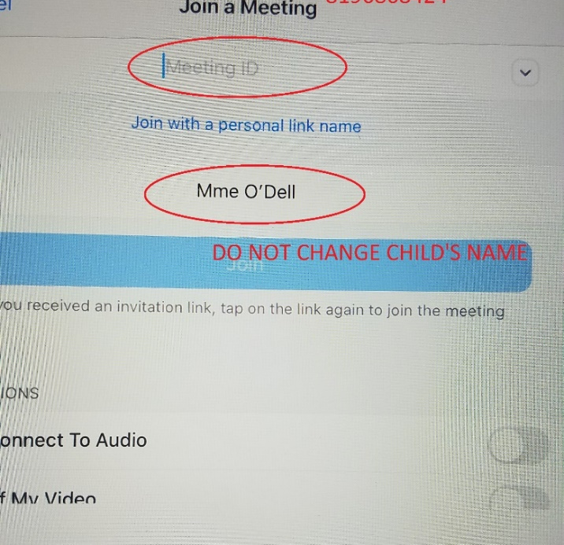
Frau Glenn

4) Touch “Join.”
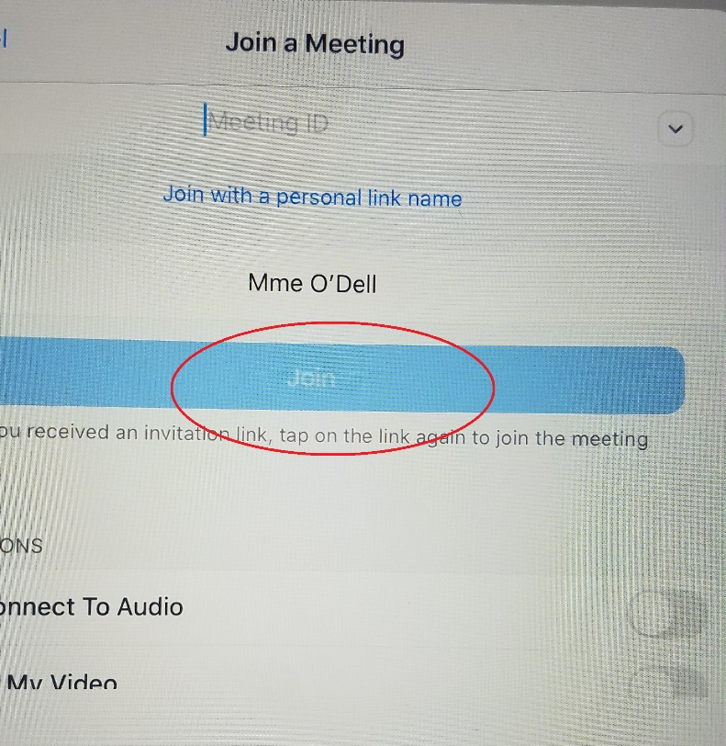
Frau Glenn
5) Put the password, “glenn” and touch “Continue.”
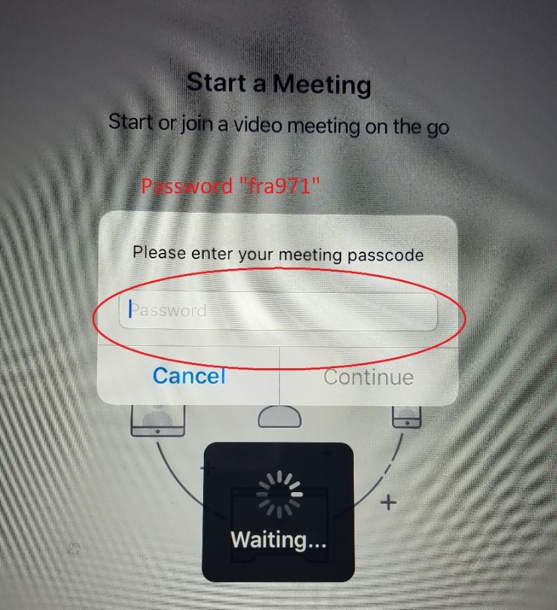

6) Touch “Join the meeting.”
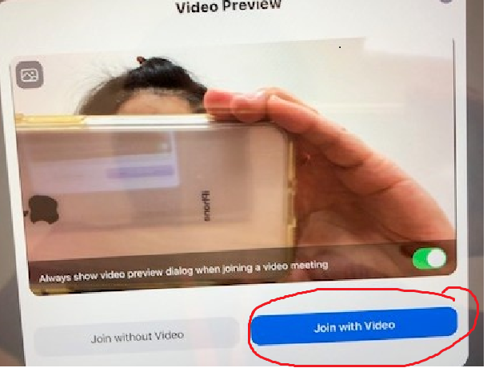

7) Touch “Call using Internet Audio.”
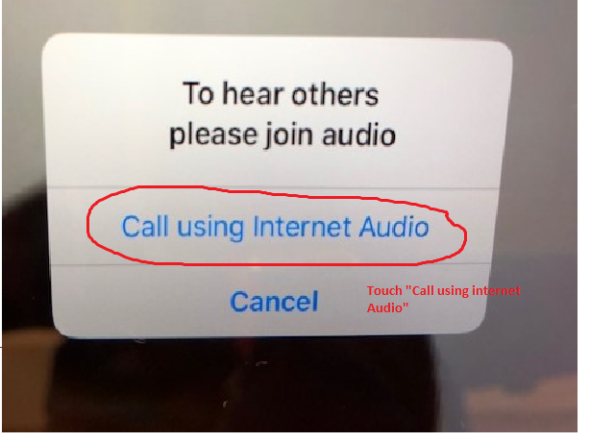
8) Your child can join the meeting!!

9) To re-enter to the ZOOM meeting. Use “history.” Touch the arrow on the right side ① and choose the person’s class that you want to join ②. Then touch “DONE.” ③ It will take you to the class.
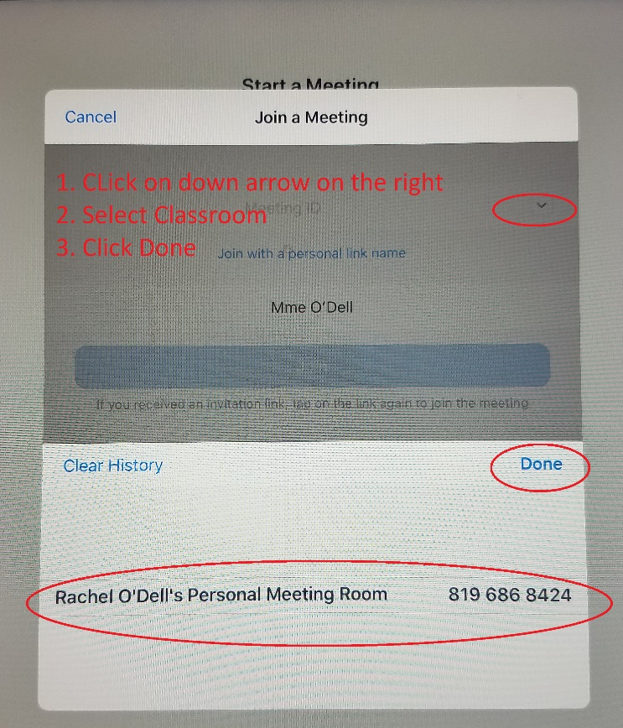
Frau Glenn’s class meeting
Frau Glenn

***Please use your child’s name. DO NOT change your child’s name to other names. I cannot allow the person who I do not know to join my class for security reasons. Thank you!

Here are the rules of our Zoom Meets:
1. Be there and don't be late!
2. Turn on the camera, I want to see your face. :)
3. Use your child's name as a screen name. I need to be able to see their name to be bale to admit them into the meeting.
4. Students should be dressed appropriately.
5. Students should be sitting in an assigned workspace. Please don't be in a bed or on a couch. The students need to be able to write, cut and glue, etc. They should also not be walking around, eating or watch TV in the background.
​
6. Have all materials ready. (See list on schedule.)

