How to login to CANVAS:

1. Find this icon in the iPad

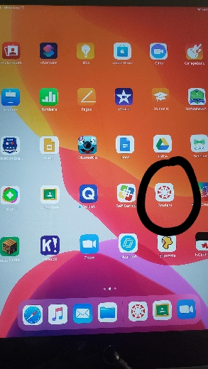

1. Click on “find my school”

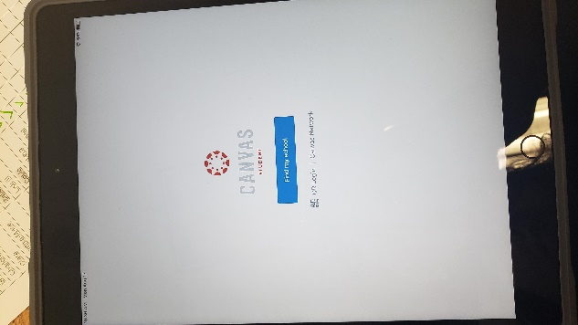

1. Put in CMS as our school (NOT Waddell)

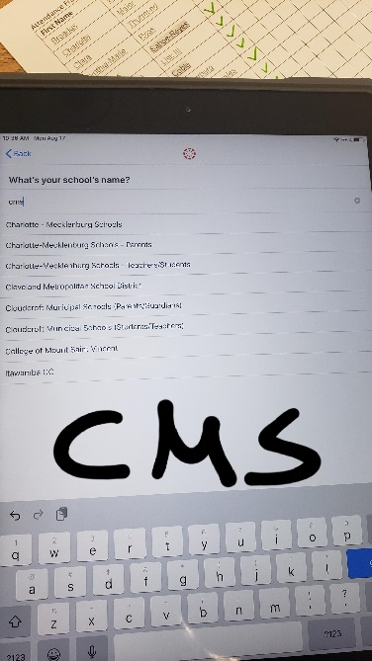

1. Click on login with NCEdCloud

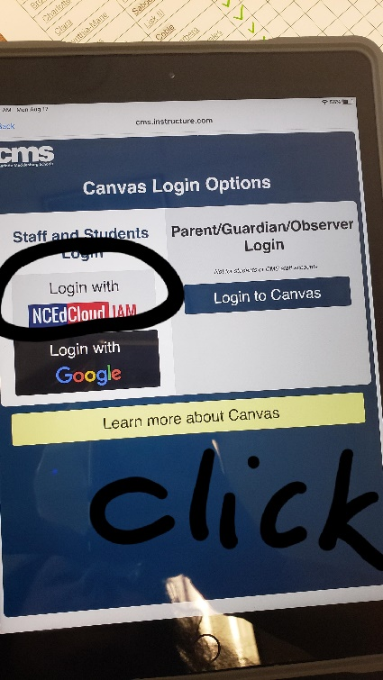

1. Login with your Student Number and password (Cmsx2031). This information was send home in your child’s iPad bag, email me if you need it)

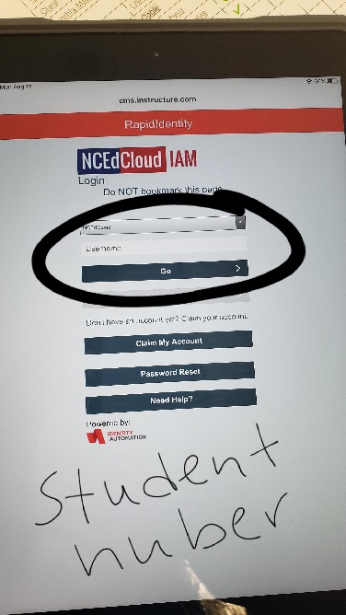

1. You should see the following screen with all the CANVAS courses:

